- Download the app from the App Store, search ‘seesaw family’.  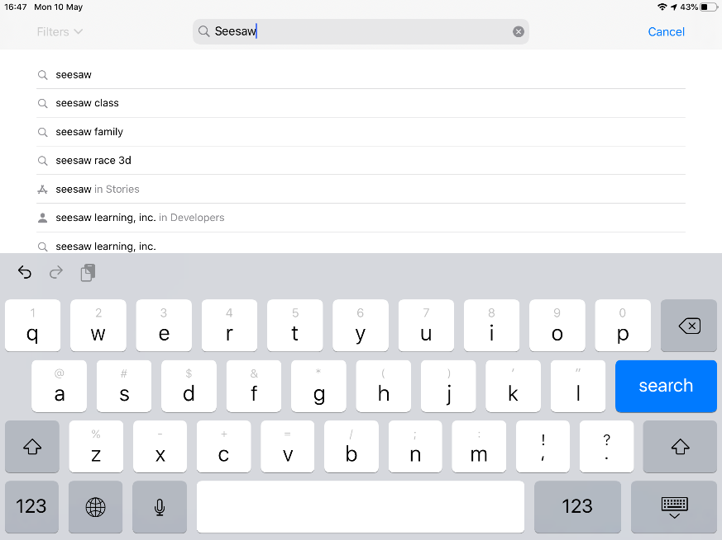 | - Sign into the app using the QR code provided by the school. You might have to enable camera access first.  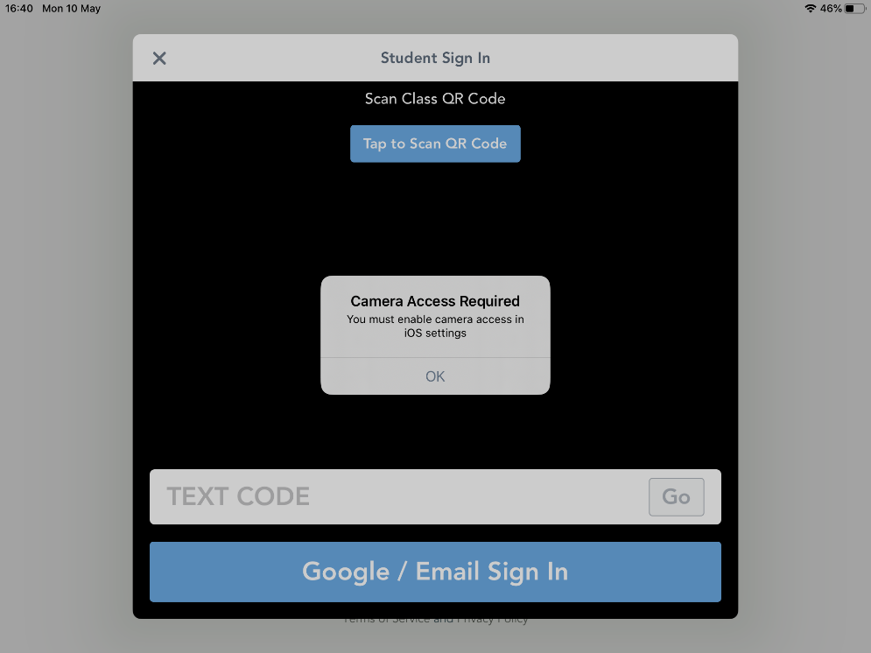
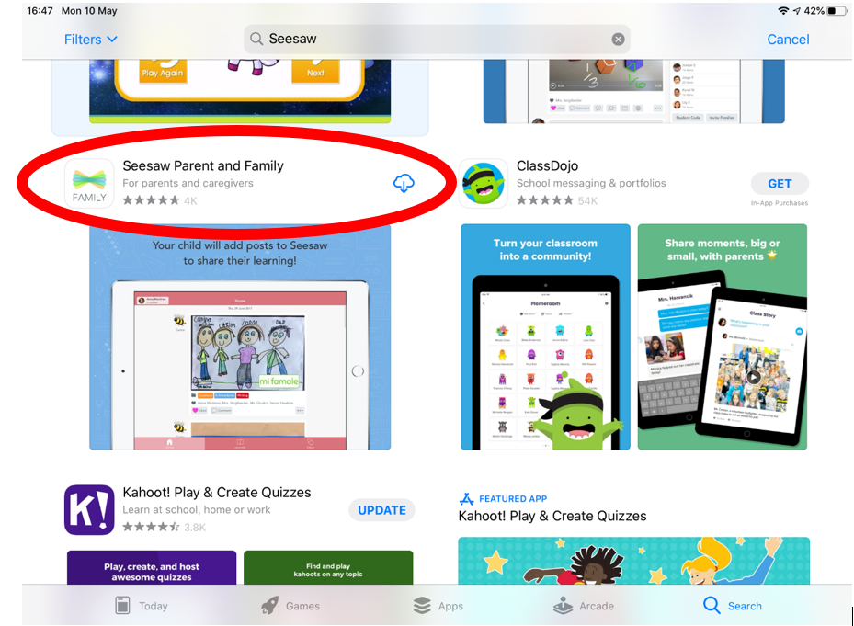 | 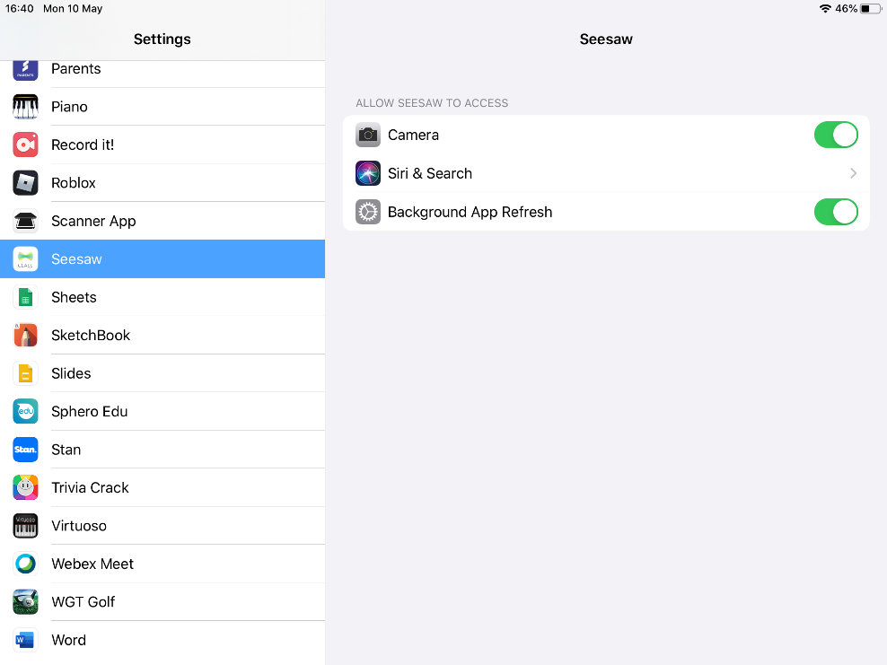
- Open the app and Scan the QR code to sign in.  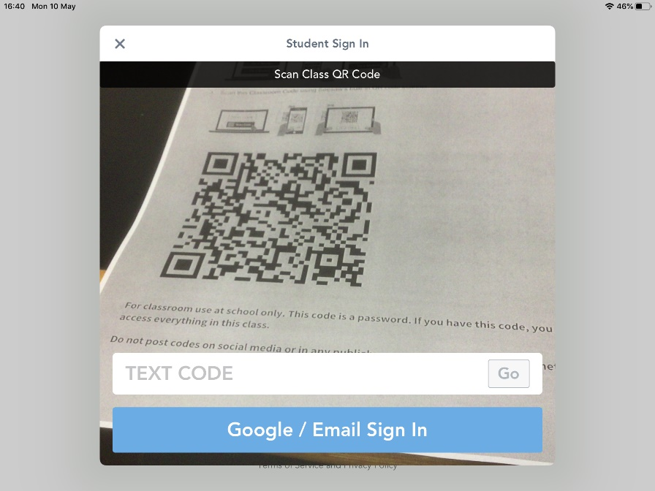 | 5. Choose an option from the list, usually you will take a photo of your work.  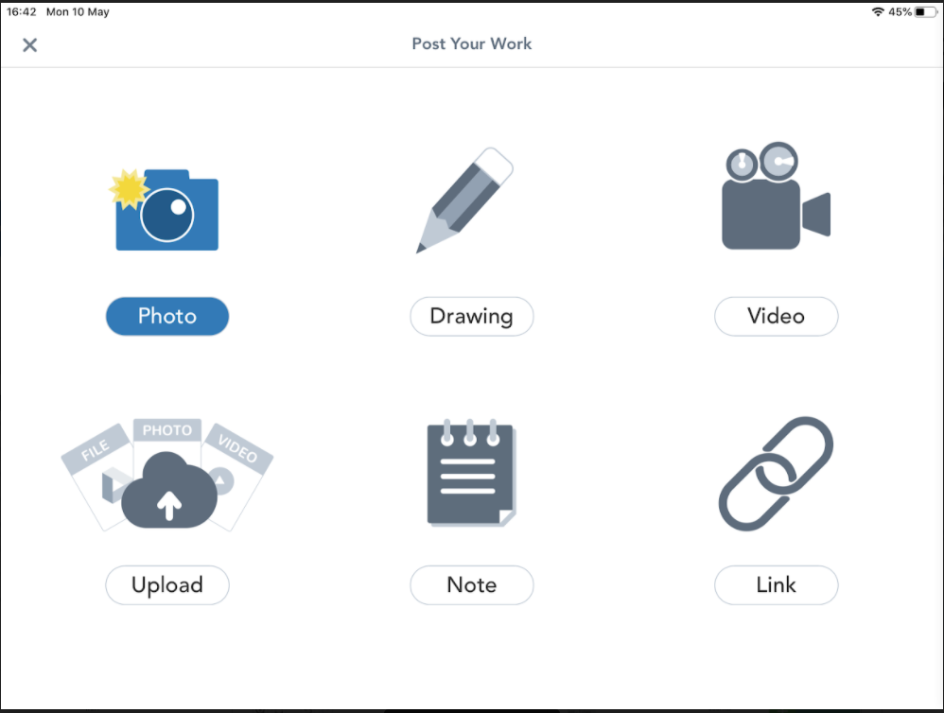
- Once you have signed in press the ‘+ADD’ to post your work.  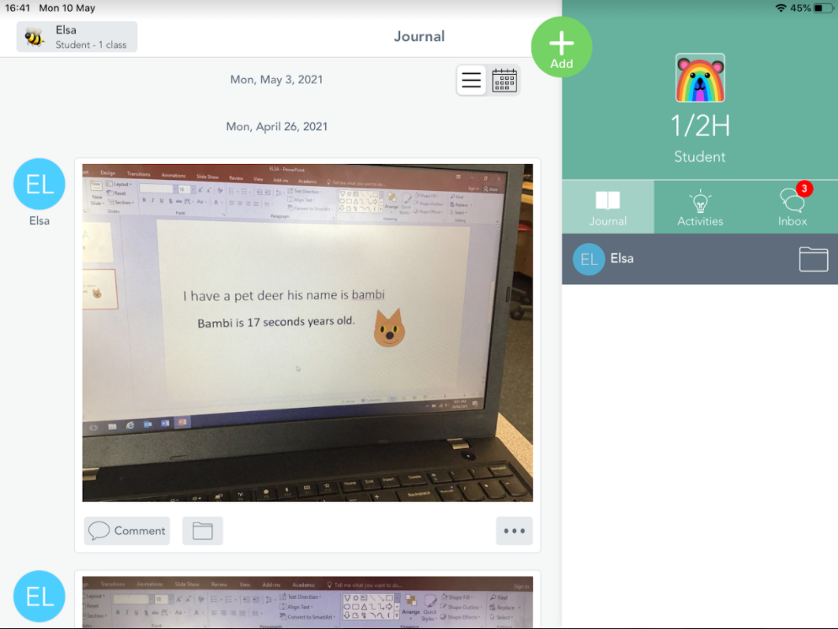  6. Once you have taken a photo you like, you can add to it by drawing, typing (T), or recording your voice. To post your work press the tick.  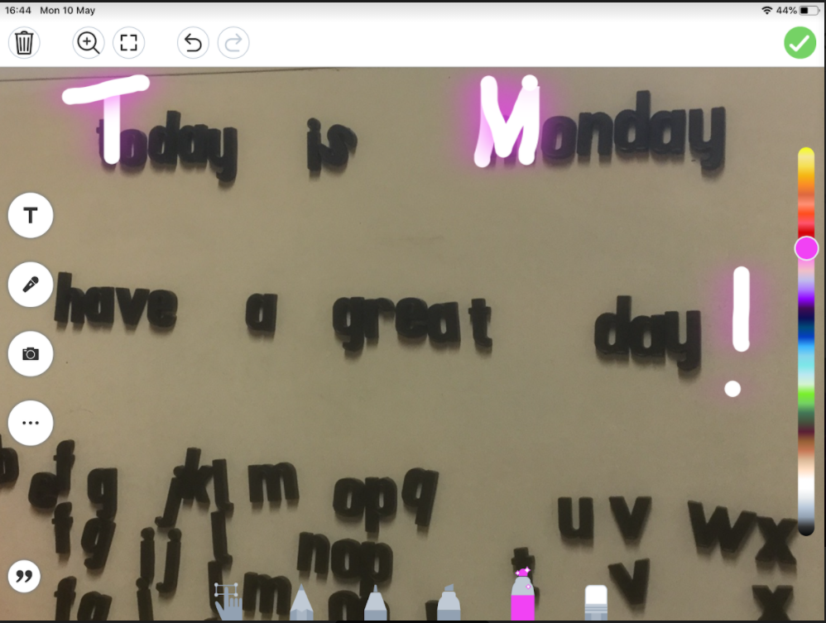 | 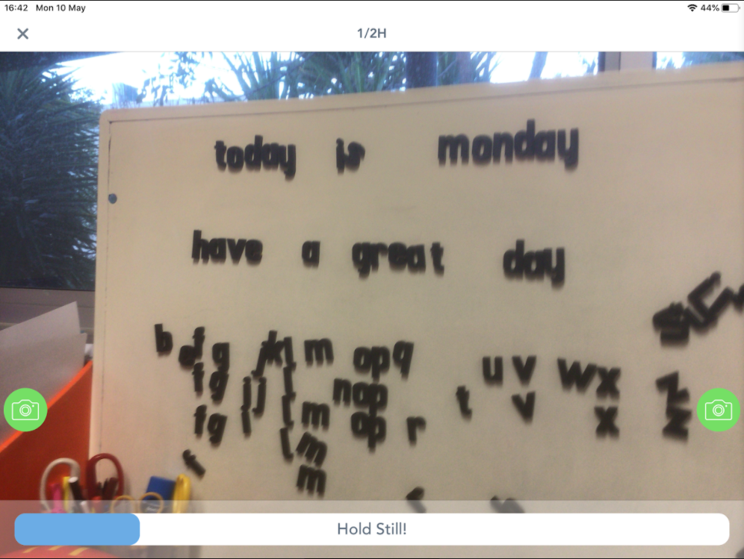  7. Your work will now be added to the ‘Journal’ waiting for your teacher to ‘Approve’ it.  